LiverDCE Software Manual

Purpose
LiverDCE is a program created to perform pharmacokinetic analyses of dynamic contrast-enhanced MRI data sets imaged using hepatospecific contrast agents for research purposes only. It is not intended for clinical use and the software license does not permit clinical use.

Installation

Prerequisites
MATLAB® R2023a Update 4 (www.mathworks.com)

MATLAB® Toolbox Dependencies
The LiverDCE software makes use of the following MATLAB® toolboxes:
- Medical Imaging Toolbox
- Optimization Toolbox
- Global Optimization Toolbox
- Image Processing Toolbox
- Parallel Computing Toolbox
- Curve Fitting Toolbox
- Signal Processing Toolbox
- Statistics and Machine Learning Toolbox
- Symbolic Math Toolbox
Type ver in the MATLAB® Command Window to see a list of all installed toolboxes.

Third-Party Packages
This manual assumes you are familiar with Git, GitHub, and MATLAB®. If you are not familiar with these tools, there are many tutorials on the web to learn about Git and GitHub and MATLAB® includes extensive documentation. MATLAB®’s documentation can be accessed either by typing doc in the Command Window or by clicking the Help button in the main window. A tutorial on Git, GitHub, or MATLAB® is beyond the scope of this manual.
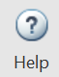

imtool3D
LiverDCE uses a customized version of imtool3D based on the version on the MATLAB® Central File Exchange but altered for integration with the LiverDCE application. This customized version of the code is available at https://github.com/MSU-Radiology/imtool3D. Login to your GitHub account and clone the repository to your computer.

afni_matlab
The afni_matlab source code is available at https://github.com/zsaad/afni_matlab. Clone the repository to your computer.

Obtaining LiverDCE from the GitHub Repository
The LiverDCE source code is available at https://github.com/MSU-Radiology/LiverDCE. Clone the repository to your computer.

Setting the MATLAB Path
Each of the third-party packages (imtool3D and afni_matlab) as well as the main LiverDCE source code must be accessible on the MATLAB® path in order for the program to function properly. Add the folders where you have placed this source code as well as any subfolders to the MATLAB® path, excluding the “.git”, “gui prototypes”, “test data”, “unused”, and “designs” folders, and save it. Follow topic Change Folders on Search Path in the MATLAB® help documentation for details on how to add folders to the path.

Launching the LiverDCE Program
To launch the program, type liverdce on the command line in MATLAB®. Note that the LiverDCE program and its dependencies must all be on your MATLAB® path in order for the program to function. LiverDCE was developed and tested on Microsoft® Windows 10 and 11. It has not been tested on macOS or Linux.

LiverDCE’s Graphical User Interface
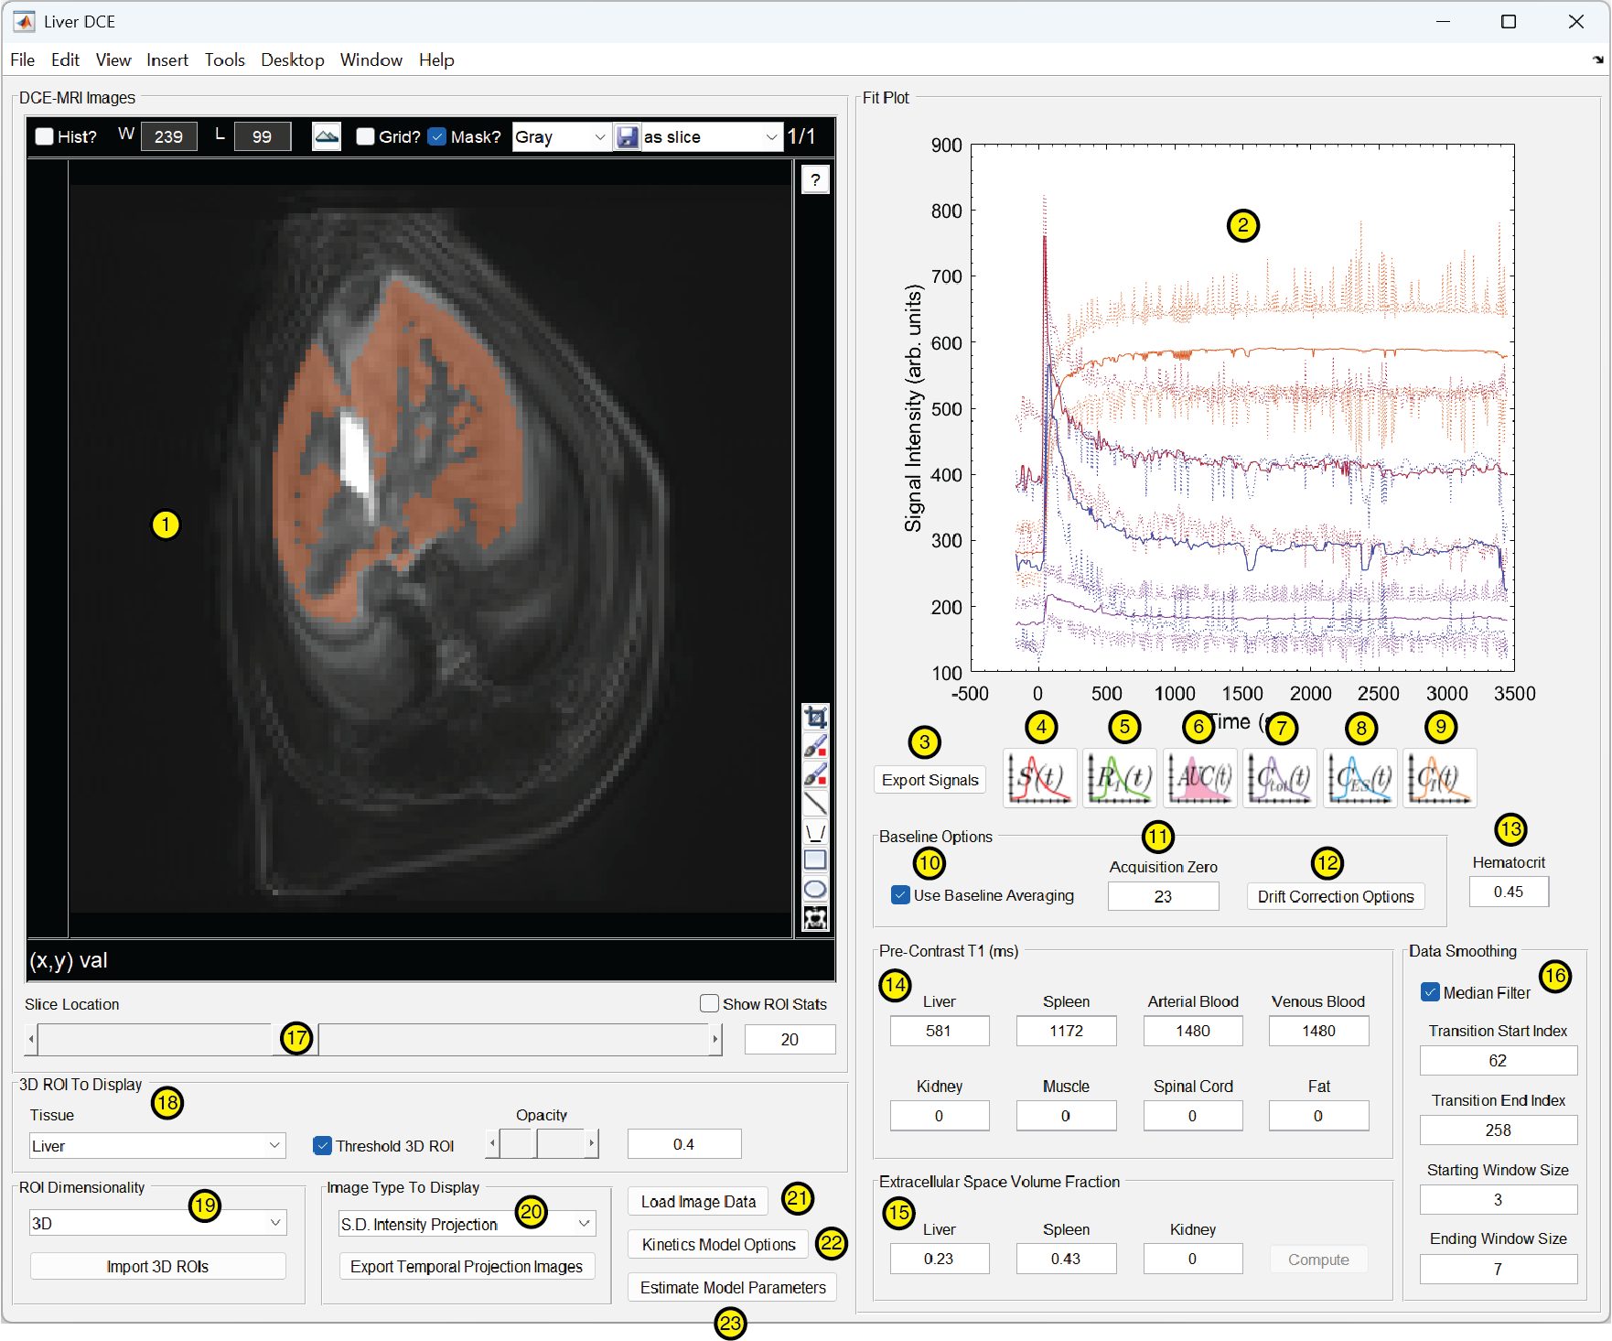
The main application window features a viewport for image display and another for plots , as well as text boxes for entering parameters used in the analysis, controls for manipulating the image display, buttons to display different types of plots, etc. When the Image Type To Display is set to Dynamic Contrast Enhanced, a vertical scroll bar is displayed to the left of the image display and using the mouse scroll wheel, clicking the arrow buttons at the ends of the scroll bar, clicking on the track of the scroll bar, or left clicking and dragging the thumb of the scroll bar (position marker) navigates through the timeline of the DCE-MRI series. Images are ordered with the first acquisition at the bottom and the last acquisition at the top of the scroll bar. The vertical scroll bar is not displayed when the Image Type To Display is set to any of the projection image types because these temporal projections collapse the 4D DCE acquisition into a static image volume with 3 spatial dimensions and no temporal dimension. A horizontal scroll bar below the image display changes the Slice Location displayed. The text box to the right of this scroll bar shows the displayed slice’s index number.
The window width and level can be adjusted either by clicking in the viewport with the left mouse button and dragging or by typing numerical values in the boxes labeled W and L at the top of the viewport. Dragging up or down adjusts the window level. Dragging left or right adjusts the window width. Changing the Image Type To Display resets the window settings to the default for the displayed image type. When 3D ROIs are loaded into the program, the Tissue drop-down menu, located in the 3D ROI To Display panel, selects which ROI to display as a semi-transparent overlay. The Opacity scroll bar and text box to its right adjust the transparency of the ROI overlays. The Threshold 3D ROI check box displays the vascular ROIs after application of thresholding if checked or displays the original ROIs without thresholding if unchecked. The check box only affects the display panel in the application. Regardless of whether the box is checked, thresholding is always applied to vascular ROIs when they are used for fitting a pharmacokinetic model.
Clicking and dragging in the viewport with the right mouse button pans the image. Clicking and dragging in the viewport with the middle mouse button zooms the image. Clicking the button at the top of the viewport resets the pan and zoom settings. The crop tool , paintbrush tools and , and the line tool are parts of the imtool3D package that are not used by LiverDCE and will likely be removed in the future.
LiverDCE has support for 2D ROIs, which are useful for quickly examining data as a quality control check. However, unlike the 3D ROIs, the 2D ROIs implemented in LiverDCE are not affixed to a particular slice location. They apply to whatever slice is currently displayed in the viewport. This constrains their usefulness for performing pharmacokinetic analyses by requiring all relevant anatomy to be present within a single slice. We recommend using 3D ROIs instead for pharmacokinetic analyses.
If using 2D ROIs to fit a pharmacokinetic model or to display any of the plots except the raw signal intensity, ROIs must first be associated with a tissue type. This can be done either by clicking the button and selecting the tissue from the tissue type picker before drawing the ROI or by drawing the ROI first and then clicking on it with the right mouse button, selecting Change tissue from the menu, and then selecting the tissue from the picker. 2D ROIs are drawn using the polygon , rectangle , or ellipse tools.

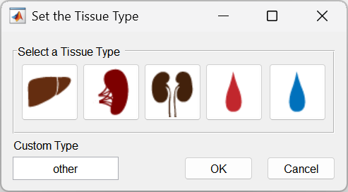
3D ROIs are created outside of the LiverDCE program using MATLAB®’s Medical Image Labeler app. More explanation regarding how 3D ROIs are created will be discussed later in this manual.

Performing an Analysis with LiverDCE

Loading the Images
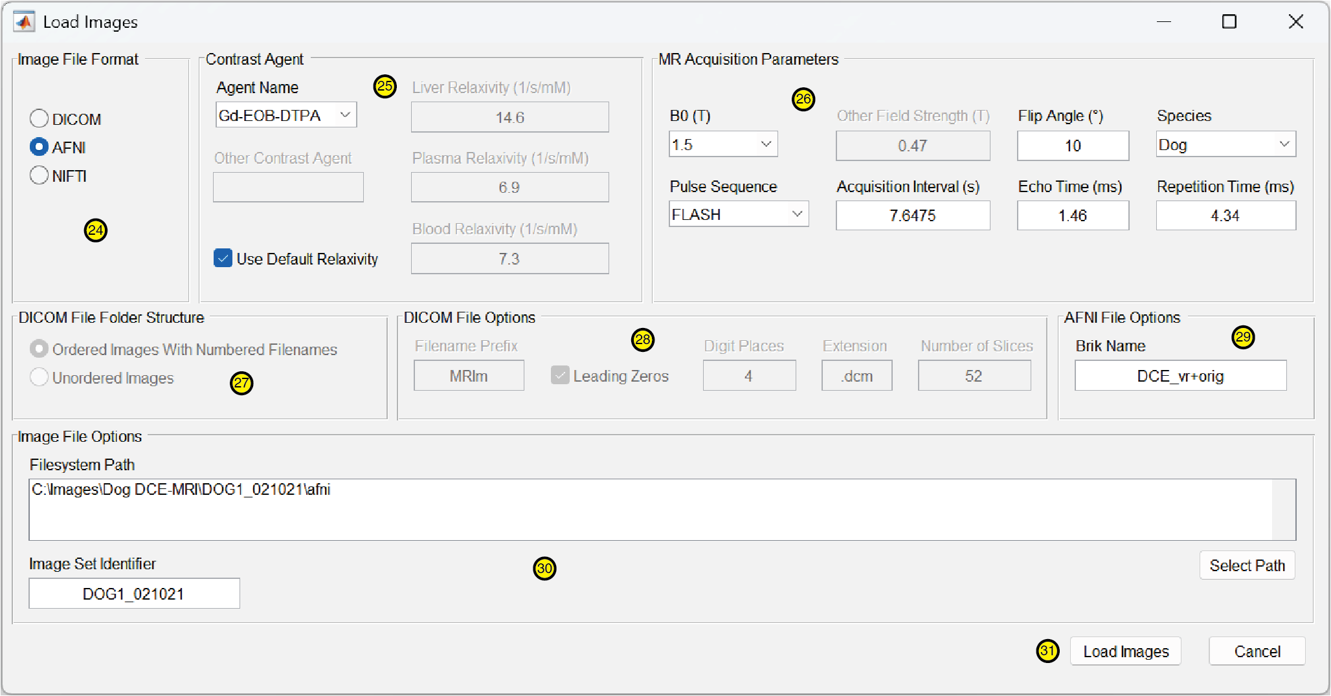
To load images into the program, click the Load Image Data button. This will pop up the Load Images dialog window. Select the file format for the images you want to load in the Image File Format panel. LiverDCE supports working with images in DICOM, AFNI .HEAD and .BRIK pairs, or NIFTI .nii files. Some of the other controls in the Load Images dialog may be grayed out (disabled) if they are not applicable to the selected file format. For example, when either AFNI or NIFTI are selected, the DICOM File Options panel is disabled. Likewise, when DICOM is selected, the AFNI File Options panel is disabled.
AFNI provides useful tools for performing bulk motion correction, which is why we used it for the data sets in our paper. However, an explanation of how to perform motion correction with AFNI is beyond the scope of this manual. We refer the reader to the AFNI documentation for details.
In the MR Acquisition Parameters panel, choose the appropriate B0 magnetic field strength for your MRI from the drop-down menu. If your magnet is energized at a different field strength from the listed values, choose Other and then type in the field strength in Tesla in the Other Field Strength text box. If you have selected DICOM as the Image File Format, the Flip Angle, Echo Time, and Repetition Time fields will be grayed out (disabled) because LiverDCE is able to obtain those parameters directly from the file metadata. Otherwise, fill in these values for your scan. Choose your Pulse Sequence from the drop-down menu. This value determines which signal equation is used when converting signal intensity values to concentration of the contrast agent. FLASH and RARE are the available options. Other pulse sequences are not supported. However, if you are using another pulse sequence that is a variant of a gradient echo pulse sequence, the underlying signal equation may be the same as the one for FLASH or RARE. If so, choose the one with the appropriate signal equation for your data. Fill in the Acquisition Interval text box with the time in seconds to acquire a single volume of your DCE series.
Select the Species that was scanned in drop-down menu. The supported options are Human, Pig, Dog, Rat, and Mouse. Together, the selected species, contrast agent, and B0 field strength determine the default in situ relaxivity values used. If you’ve scanned a species that is not on the list, choose the species associated with the relaxivity values you wish to use if there is a suitable option. If needed, you can adjust the relaxivity values after you select the contrast agent and B0.
In the Contrast Agent panel, choose the contrast agent for the scan from the Agent Name drop-down menu. If your contrast agent is not listed, choose Other, record the name of the agent in the Other Contrast Agent field, and fill in the Liver Relaxivity, Plasma Relaxivity, and Blood Relaxivity text boxes with values in the appropriate units (1/s/mM) for the agent. For contrast agents that are specifically named in the menu, relaxivity values are populated automatically based on the Species and the B0 (magnetic field strength) that were selected in the MR Acquisition Parameters panel. Although we’ve provided estimates for the in situ relaxivity of the listed contrast agents, you may wish to use different values if more accurate measurements become available or if the species you scanned is not on the list. To supply your own relaxivity values, uncheck the Use Default Relaxivity checkbox and fill in the text boxes for the liver, plasma, and blood relaxivity of the agent for the species.
If you are loading images in DICOM format, ensure that the DICOM File Folder Structure option is set to Ordered Images With Numbered Filenames. The other option, Unordered Images, is not yet implemented and fails silently without an error message. LiverDCE expects DICOM images to be organized in alphanumeric order by their filenames. If your DICOM files are not already ordered by spatial location and temporal position with filenames that conform to the format expected by LiverDCE, you will need to use a third-party utility to arrange the files in a total ordering with filenames that match the expected format before they can be loaded into LiverDCE. Alternatively, you may import a collection of DICOM files into AFNI and convert them into AFNI’s file format, which is supported by LiverDCE.
LiverDCE’s expected filename structure for DICOM files consists of a Filename Prefix that is a fixed alphanumeric string that begins each filename, followed by an integer that indicates the place of the file within the ordering, and an optional Extension (which defaults to .dcm) that follows the integer. The Digit Places option sets the maximum number of digits for the integer portion of the filename. The Leading Zeros checkbox, if checked, tells LiverDCE that the integer values are padded with leading zeros such that the numbers all have the number of digits specified by the Digit Places option. For example, with Leading Zeros unchecked, the first integer is 1. With Leading Zeros checked and Digit Places set to 6, the first integer is 000001. The Number Of Slices parameter specifies how many slices are within a single acquired 3D volume image. The total number of DCE images should be equal to the Number Of Slices multiplied by the number of acquired volumes (e.g., the number of temporal positions).
If you are loading images in AFNI or NIFTI format, type the filename without the file extension for your file in the Brik Name text box. When the AFNI format is selected, LiverDCE expects a pair of files named filename.HEAD and filename.BRIK, respectively, where filename is the value you entered in the Brik Name text box. When the NIFTI format is selected, LiverDCE expects to find a single file named either filename.nii or filename.nii.gz.
The Image Set Identifier text box specifies the name that will be used for the Microsoft® Excel spreadsheet tabs generated when the Export Signals button is clicked. This may be left blank if you do not intend to export the signal information to a spreadsheet. Otherwise, ensure that whatever you enter follows the naming rules for tabs in Excel and is no longer than 13 characters, to allow for LiverDCE to add a suffix to distinguish the two tabs it generates. We refer the reader to Excel’s help documentation for information about naming tabs.
When you have filled in all of the required information, click the Load Images button to commence loading the images into LiverDCE. If the images load successfully, they will be displayed in the DCE-MRI Images viewport.

Generating Temporal Projection Images
Temporal projection images summarize the information contained in a 4D DCE-MRI acquisition, collapsing its time dimension to form of a single, static 3D image. Different temporal projections emphasize or deemphasize different features of the data. For example, the contrast agent peak is emphasized by a maximum intensity projection, and this projection is very useful for visualizing the vasculature. Mean intensity projections deemphasize transient noise such as respiratory motion artifacts. Standard deviation intensity projections emphasize features that change drastically over time, such as the bile ducts, which are initially isointense with the liver parenchyma but enhance in the late phase as hepatocyte efflux occurs and hepatospecific contrast agents accumulate in them.
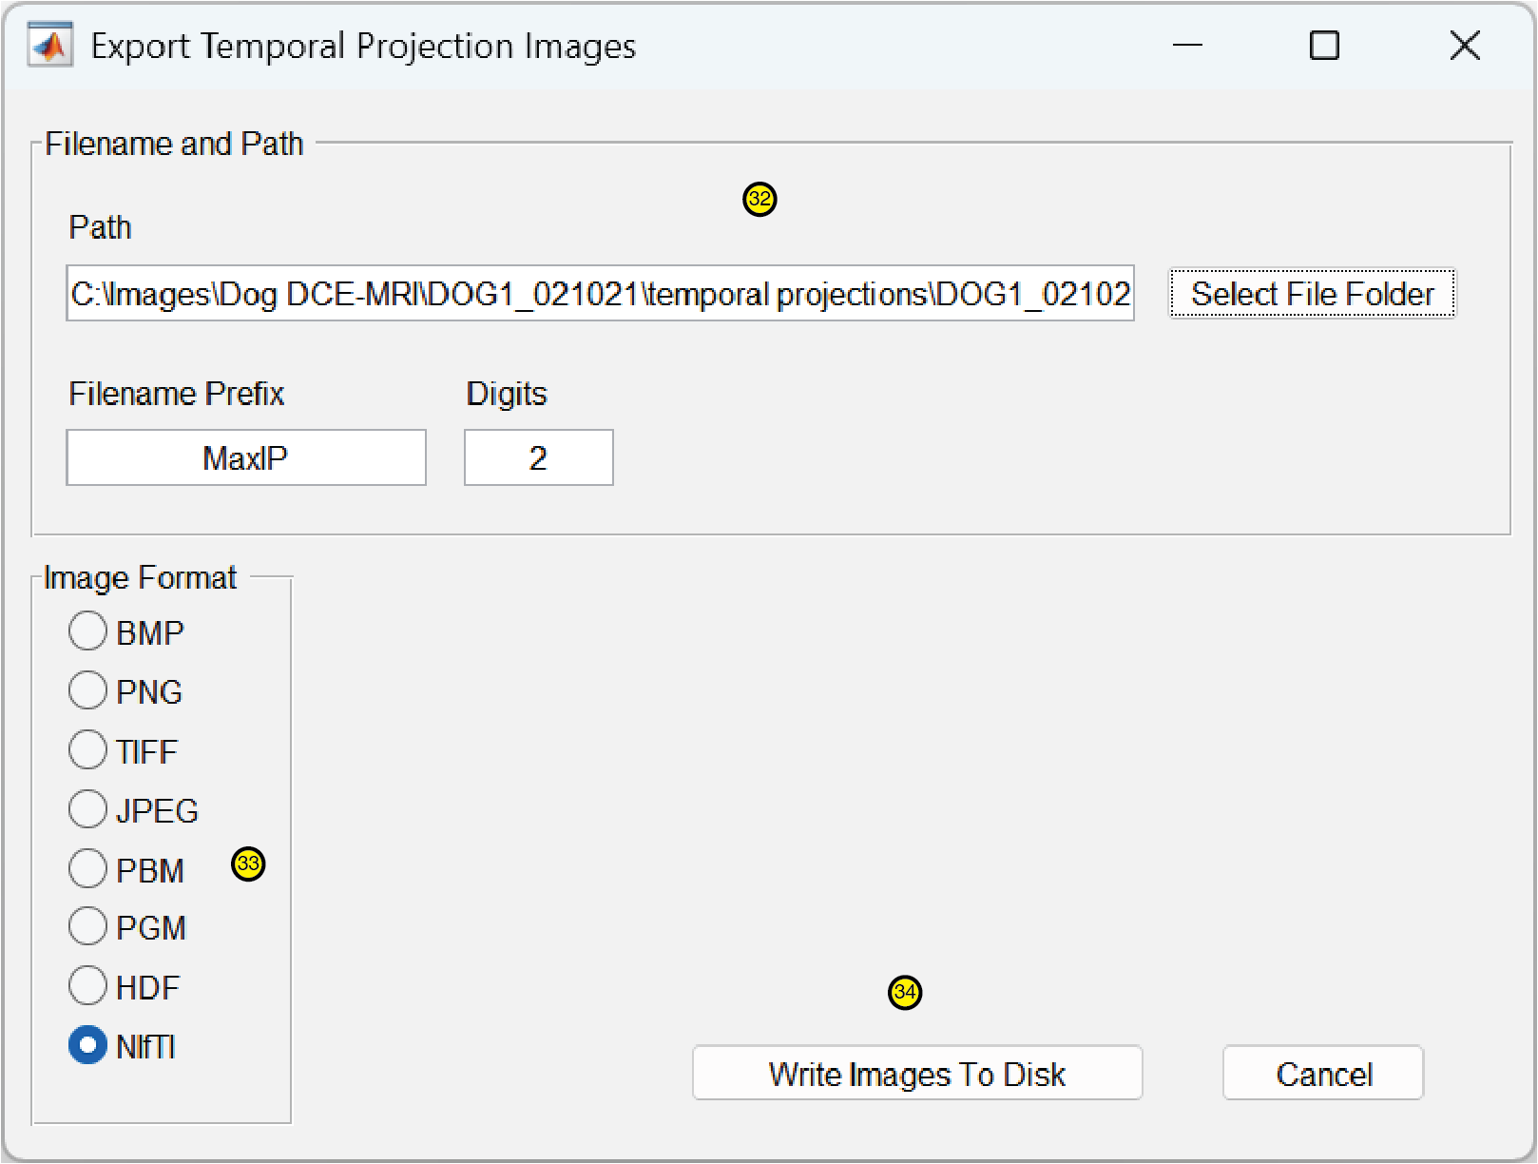
To display a temporal projection image, select the Image Type To Display from the drop-down menu. To save the temporal projection images, click the Export Temporal Projection Images button. In the Filename and Path panel of the dialog box that appears, click the Select File Folder button and navigate to the folder on the filesystem where you wish to export the temporal projection images. The Filename Prefix option is set automatically for the type of temporal projection that was generated. Leave this with the default prefix when exporting projection images that will be used for defining 3D ROIs to use in LiverDCE.
The Digits text box indicates the number of digits necessary to represent the numerical indices of all the individual slices of the image volume when using a 2D format to export images. The 2D file format options are provided to facilitate generating temporal projections for use with third-party applications. You can ignore the Digits setting when exporting images in a multiframe file format such as NIFTI that represents the 3D projection in a single file. To define 3D ROIs for use with LiverDCE, select NIFTI in the Image Format panel.
To return to displaying the original DCE series, pick Dynamic Contrast Enhanced from the Image Type To Display drop-down menu. To perform a pharmacokinetic analysis with 3D ROIs, you will need to generate temporal projections to be used in defining the ROIs. At a minimum, a Mean Intensity Projection is needed for drawing the liver (and, if a reference region model is to be used, spleen) ROI. If the chosen pharmacokinetic model requires vascular inputs (as is the case for the Berks and Georgiou models), you will also need a Maximum Intensity Projection.

Drawing the Regions of Interest
To define 3D ROIs for pharmacokinetic analysis in LiverDCE, we use MATLAB®’s Medical Image Labeler app, which can be found on the Apps tab of the main MATLAB® window .
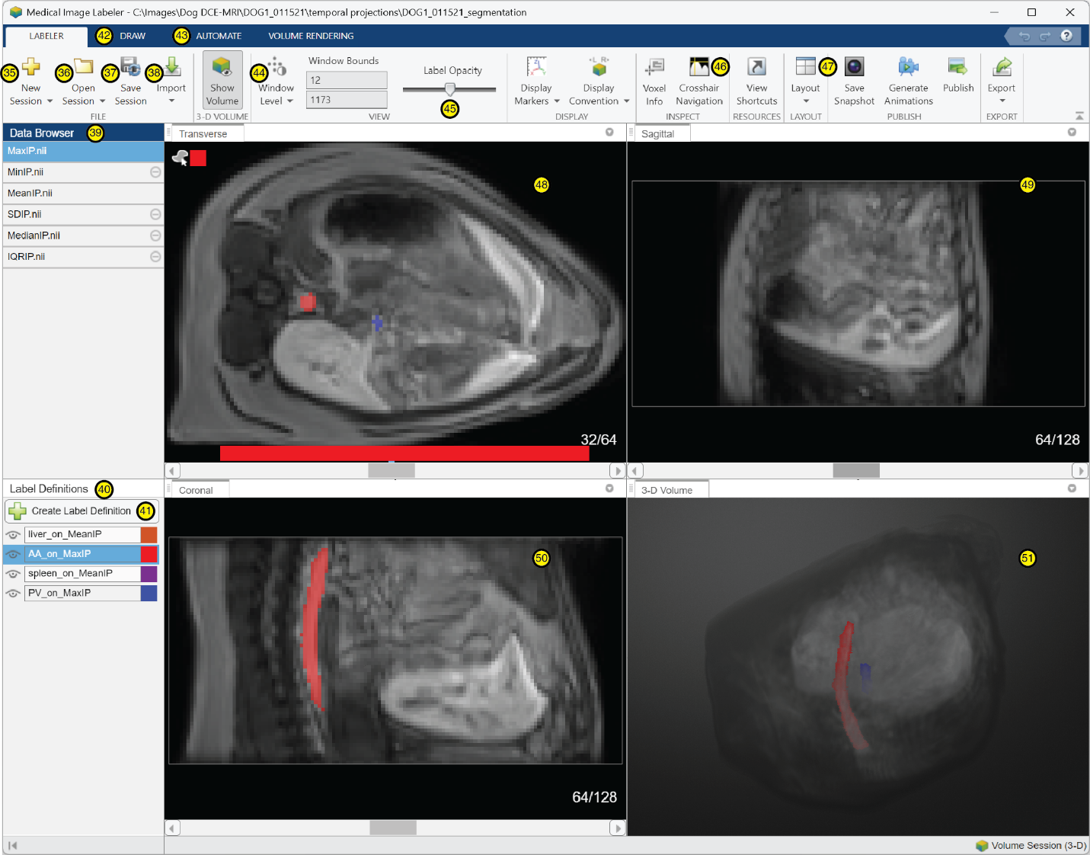
To begin defining 3D ROIs for a new image set, click on the New Session button. To resume working on a previously created session, click the Open Session button. Once the session has been created, click the Import button and select Data, From File from the menu to load the temporal projection images from a .nii (NIFTI) file into the Medical Image Labeler. Repeat this step for each of the temporal projection files associated with the imaging study. The LiverDCE program specifically expects the .nii files used for pharmacokinetic analyses to be named MaxIP.nii and MeanIP.nii.
To create a 3D ROI, first click in the Data Browser section on the appropriate temporal projection that will be used as the anatomical reference (MeanIP.nii for defining organ ROIs or MaxIP.nii for defining vascular ROIs) to select it. Then click on the Create Label Definition button in the Label Definitions section to begin defining the ROI. Give the ROI a meaningful name that fully identifies both the tissue it represents as well as the reference projection used in defining it. ROIs that will be used for pharmacokinetic analyses within LiverDCE should be labeled using the format tissueType_on_projectionType, where tissueType is AA, PV, liver, or spleen and projectionType is MaxIP or MeanIP. For example, our analyses for the paper used the names liver_on_MeanIP, spleen_on_MeanIP, AA_on_MaxIP, and PV_on_MaxIP for the ROIs. Click on the color swatch to the right of the ROI name and select a color from the dialog box to choose the color that will be used for the ROI. The ROI will be displayed using this color within the Medical Image Labeler app, for the color overlays in LiverDCE, and for plot lines associated with the ROI in LiverDCE.
Use the tools on the DRAW and AUTOMATE tabs to define 3D ROIs. We refer the reader to MATLAB®’s documentation for details regarding use of the Medical Image Labeler app. Although a tutorial is beyond the scope of this manual, we think it worthwhile to call attention to some useful tools. The Window Level tool adjusts the mapping of signal intensity values to grayscales. The Label Opacity slider determines the extent of transparency of the color overlay for the ROI. The Crosshair Navigation tool navigates to display the three orthogonal view planes (axial , coronal , and sagittal ) that intersect at the position of the crosshairs. This tool is particularly helpful for tracking vessels in 3D space. The Layout button allows you to switch between the 2-by-2 grid display and another display, such as a single plane display. The Save Session button saves the ROI definitions in a Ground Truth file, named groundTruthMed.mat by default. This is the file that you will select when loading the 3D ROIs into the LiverDCE program.
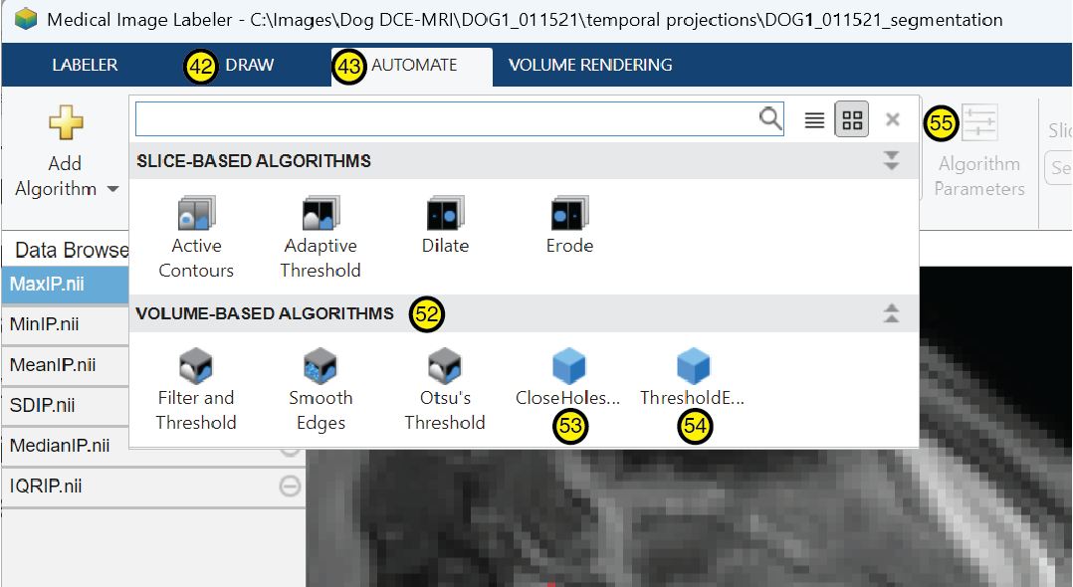
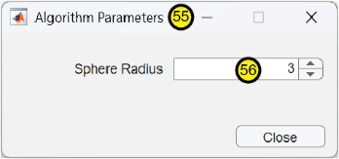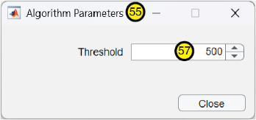
To aid in defining ROIs, we implemented two custom tools that may be installed in the app via the Add Algorithm button on the AUTOMATE tab. The code for these tools is contained in the CloseHolesInRegion.m and ThresholdExistingRegion.m files and their accompanying settings files CloseHolesInRegionSettings.m and ThresholdExistingRegionSettings.m. Once installed, buttons for these tools appear in the list of available algorithms on the AUTOMATE tab in the VOLUME BASED ALGORITHMS category. The CloseHolesInRegion tool performs morphological closure on an existing 3D ROI to eliminate holes smaller than the Sphere Radius parameter specified in its Algorithm Parameters . The ThresholdExistingRegion tool excludes voxels of an existing 3D ROI with signal intensity less than the numerical Threshold defined in its Algorithm Parameters .

Loading 3D ROIs into LiverDCE
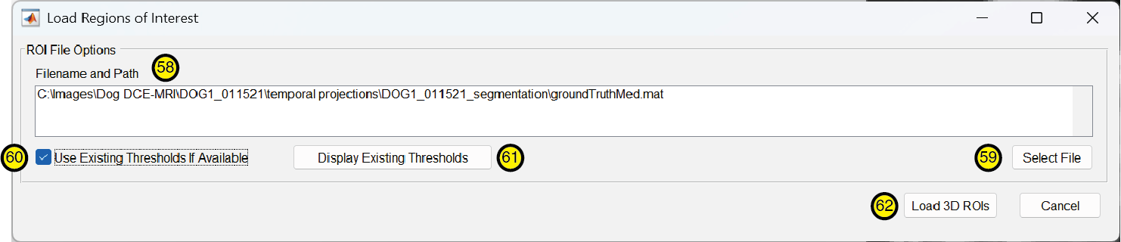
To load 3D ROIs into LiverDCE, first select 3D from the drop-down menu in the ROI Dimensionality panel. Then, click the Import 3D ROIs button. The Load Regions of Interest dialog will appear. Click the Select File button to open a file chooser and navigate to the folder where you saved your “ground truth” file from MATLAB®’s Medical Image Labeler app. By default, the file is named groundTruthMed.mat. Alternately, you can type the full qualified path to this file in the Filename and Path text box. By default, the Use Existing Threshold If Available checkbox is checked. This setting skips the procedure to select thresholds for the vascular ROIs if they’ve been thresholded previously. If, for some reason, you wish to pick different thresholds for your vascular ROIs, uncheck the box. Otherwise, leave it checked. The Display Existing Thresholds button will manually initiate the thresholding process. Alternately, clicking the Load 3D ROIs button closes the dialog and automatically initiates the thresholding process if a ground truth file was selected and the vascular ROIs have not already been thresholded.

Thresholding Vascular ROIs
When the vascular ROI thresholding procedure is initiated, a plot of the Abdominal Aorta ROI pixel values is displayed with values ranked in ascending order together with a horizontal line showing the previously chosen threshold, if there is one. You are then prompted to select a threshold for each vascular ROI using MATLAB®’s ginput graphical point selection tool.
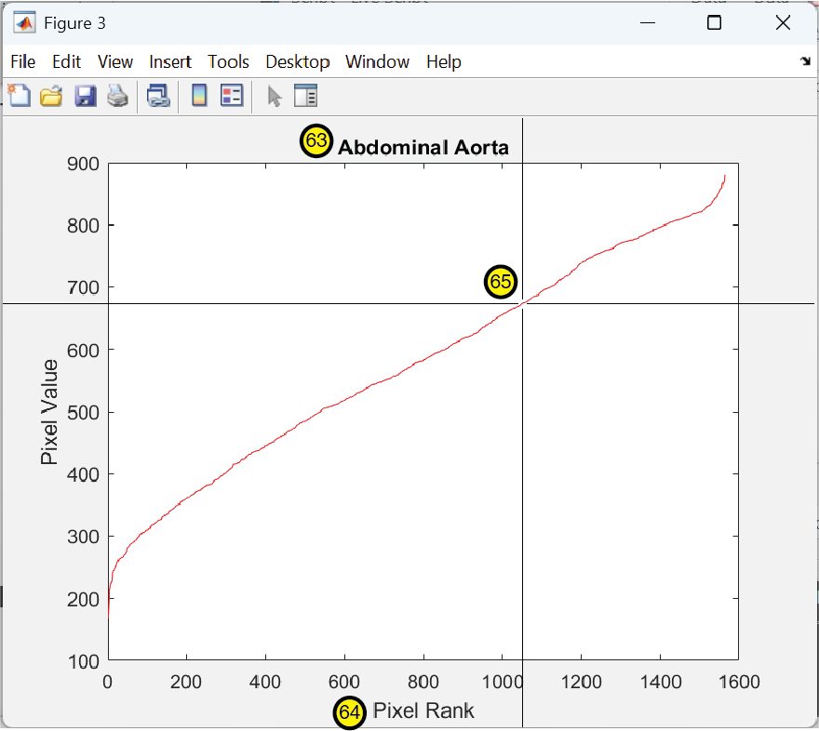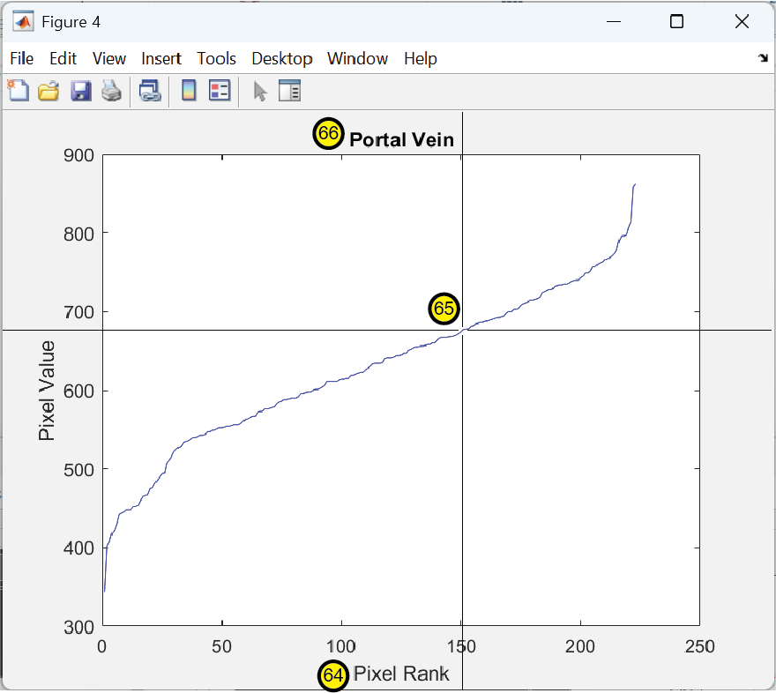
To threshold the vascular ROI, find the Pixel Rank that is approximately 2/3 of the maximum pixel rank value (i.e., approximately 1/3 of the pixel ranks are to the right of this point on the plot). Find the intersection of that pixel rank with the ascending plot line and click there. This will threshold the ROI, excluding pixels whose Pixel Value is below the horizontal line of the crosshair and retaining pixels whose value is above the horizontal line. A plot will appear showing a horizontal line representing the selected threshold. Repeat this procedure for the Portal Vein ROI.
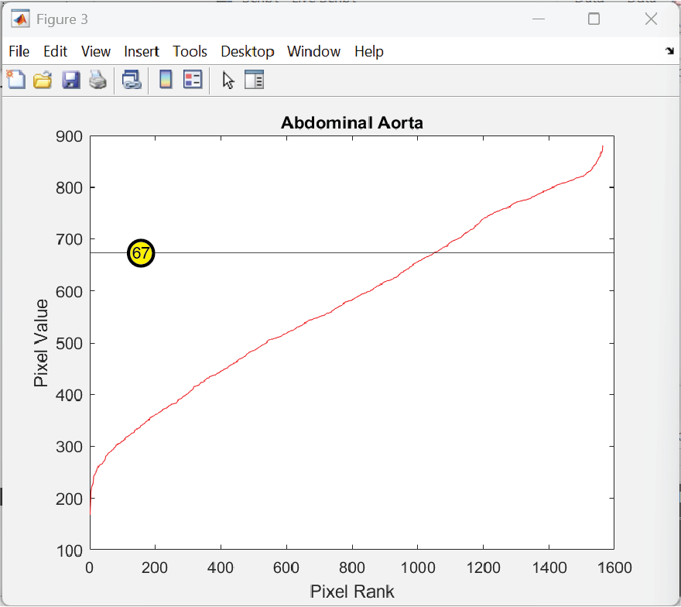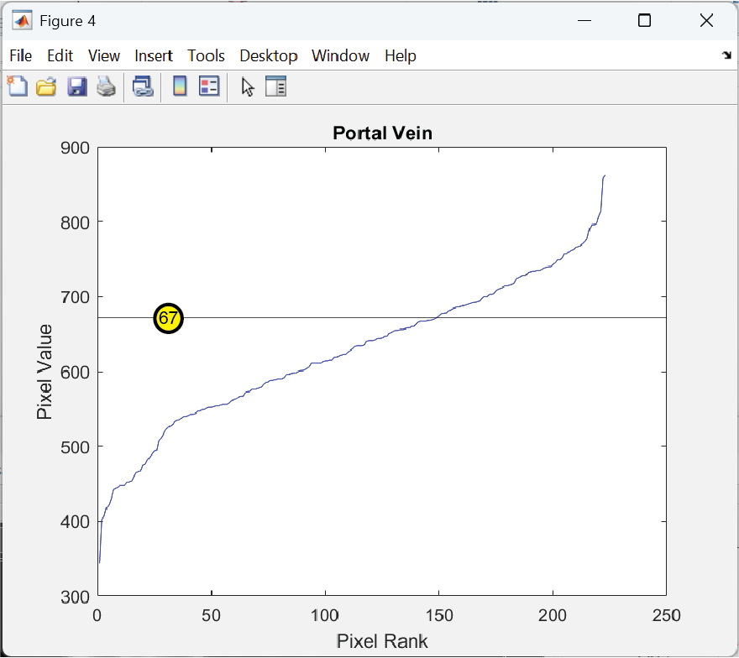

Displaying 3D ROIs
Once the 3D ROIs have been loaded into LiverDCE, a color overlay for the currently selected Tissue will display in the DCE-MRI Images panel if an ROI is defined for that tissue. If you do not see a color overlay, check to ensure that the ROI Dimensionality is set to 3D and that the Opacity is set somewhere in the middle (the default value is 0.4) or higher. Then, navigate through the different Slice Locations , as the ROI will likely not be present in some slices.
Before fitting pharmacokinetic models, a standard deviation projection should be used for quality control to check the liver ROI to ensure the common bile duct has been excluded. To view this overlay, select S.D. Intensity Projection from the Image Type To Display drop-down menu.

Setting the Pre-Contrast T1 Values
In the Pre-Contrast T1 panel, there are text boxes for each tissue type. Currently, only Liver, Spleen, Arterial Blood, and Venous Blood are used by the program. Initially, these text boxes are populated with reasonable default values for small rodents (mice, rats) imaged at 7 T. If you imaged a different species or at a different B0 field strength, these values should be replaced with T1 relaxation times in ms for the relevant species at the relevant field strength.

Setting the Extracellular Space Volume Fractions
The Extracellular Space Volume Fraction panel sets the values used for the fraction of the tissue volume that consists of the extravascular extracellular space. Only Liver and Spleen values are currently used by the program. These values are set automatically to the values given in: Ulloa JL, Stahl S, Yates J, et al (2013) Assessment of gadoxetate DCE-MRI as a biomarker of hepatobiliary transporter inhibition. NMR Biomed 26:1258–1270. https://doi.org/10.1002/nbm.2946. Although these values are for rats, it is reasonable to use them for other mammals if no species-specific measurements are available. They may be replaced with other values if desired. Volume fractions range between zero and one.

Setting Baseline Options
The Baseline Options panel sets parameters relating to the pre-contrast DCE-MRI images used as a baseline reference for comparison with the post-contrast images. The Use Baseline Averaging checkbox, if checked, uses the average of the ROI means of the acquisitions up to and including the Acquisition Zero acquisition to compute the baseline value for each time series. If the box is unchecked, only the ROI mean of the acquisition corresponding to the Acquisition Zero index is used for the baseline value. We recommend leaving the box checked.
The Acquisition Zero value is the acquisition number (an integer) of the volume acquired at the time of contrast bolus injection. For example, if the temporal resolution of your DCE-MRI series were 4.9 s and you delivered the bolus after collecting pre-contrast images for 1 minute, then Acquisition Zero would 12 (1 min/4.9 s = 60 s/4.9 s = 12.2, which rounds to 12 when converted to an integer).
The Drift Correction Options button launches an interface for correcting baseline drift. However, this feature remains a work-in-progress and has not been validated.

Setting Hematocrit
Set the Hematocrit for your subject by entering a value in the text box. Use the default value of 0.45 if you do not have a hematocrit measurement for your subject.

Data Smoothing Settings
If noise filtering is desired, check the Median Filter checkbox in the Data Smoothing panel. This will cause filtering to be applied to the signal intensity data before plotting the data or fitting a pharmacokinetic model. From the first acquisition to the acquisition at the Transition Start Index, a median filter with a kernel size equal to the Starting Window Size value (in samples) is applied to the data. From the acquisition at the Transition End Index, a median filter with a kernel size equal to the Ending Window Size value (in samples) is applied to the data. Between the Transition Start Index and Transition End Index, both median filters are applied separately to the data and the resulting filtered data is computed as a weighted sum of the two filtered versions. The weighting changes linearly from 1 at the Transition Start Index to 0 at the Transition End Index for the data that is filtered with the median filter having a kernel of Starting Window Size. The weighting changes linearly from 0 at the Transition Start Index to 1 at the Transition End Index for the data that is filtered with the median filter having a kernel of Ending Window Size. Note that the Transition Start Index and Transition End Index are given as acquisition numbers, not time units. To convert from time to acquisitions, divide by the temporal resolution.

Displaying Signal Plots
A variety of plots are available for examining signals obtained from ROIs applied to the DCE time series. Plots display in the Fit Plot panel. The S(t) button plots the MR signal intensity (arbitrary units) for each ROI, with the plot colors matching the colors chosen for the 3D ROIs in the Medical Image Labeler tool. The R₁(t) button plots the longitudinal relaxation rate computed from the MR signal intensity via the signal equation for the pulse sequence used for the DCE acquisition. The AUC(t) button plots the area under the concentration curve from 0 to t. The C_{tot}(t) button plots the total concentration in the tissue. The C_{ES}(t) button plots the concentration in the extracellular space of the liver. The C_{I}(t) button plots the intracellular concentration in the liver. When a pharmacokinetic model is fit to the data, a plot of the concentration data, together with the fitted model, will appear in the Fit Plot panel.

Exporting Signals to a Spreadsheet
Clicking the Export Signals button will save the mean, standard deviation, baseline, and % enhancement information (both with and without noise filtering) for each of the ROIs, together with the corresponding timing information and the noise filtering parameters used, to an Excel spreadsheet. If the spreadsheet does not exist, one will be created. If it already exists, the information will be appended in a new tab. The tab name is designated by the value that was entered in the Image Set Identifier text box of the Load Images dialog.

Choosing a Pharmacokinetic Model and Associated Options for Computation
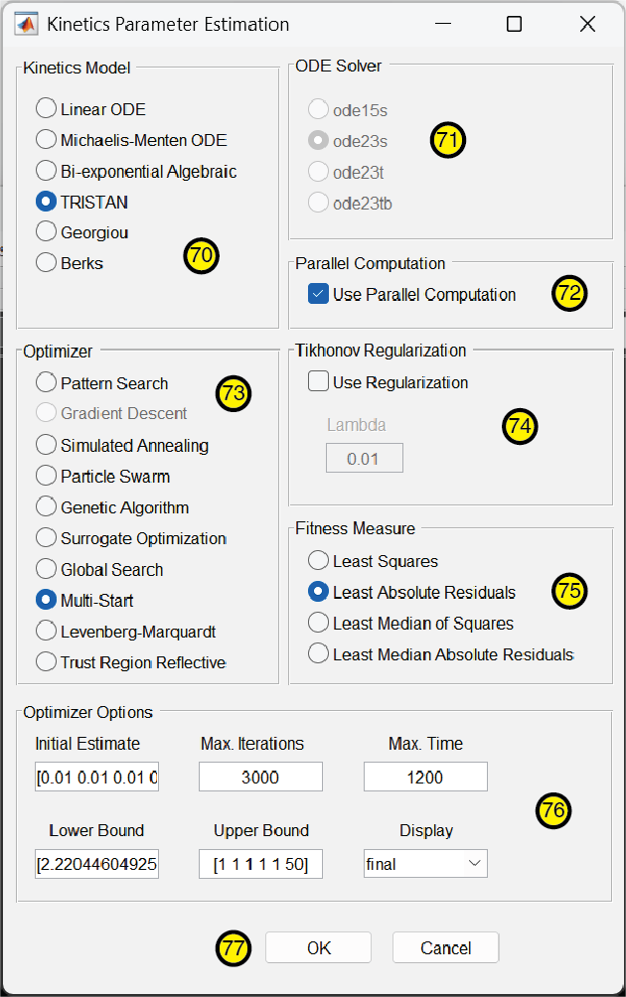
To select a pharmacokinetic model to fit your data, as well as associated options for the optimization, click the Kinetics Model Options button. This will open the Kinetics Parameter Estimation dialog. Select the model you wish to use in the Kinetics Model panel. Although included in the options, the Bi-exponential Algebraic model is a work-in-progress and is not yet functional. If you select one of the ODE models, a solver must also be selected in the ODE Solver panel. By default, the ode23s solver is selected.
The Use Parallel Computation checkbox uses parallelism to accelerate performance when running the optimizer and is turned on by default. Turning off parallel computation can be useful for debugging purposes when developing a new model, but in most other circumstances, parallel computation should be kept turned on for better performance.
Select an optimizer from the Optimizer panel. Levenberg-Marquardt and Trust Region Reflective are both local optimizers which are fast but more likely to result in local, suboptimal solutions. The other optimizers in the list are all global methods which explore the search space more extensively and are more likely to avoid converging on a suboptimal solution. Some work better than others for fitting pharmacokinetic models. We found the Multi-Start and Pattern Search optimizers to be useful.
Regularization can be applied during model fitting by checking the Use Regularization checkbox in the Tikhonov Regularization panel, if desired. The form of regularization implemented adds a term to the fitness measure which penalizes parameters of large magnitude. You may specify the coefficient of the penalty term in the Lambda text box. Select the desired Fitness Measure for fitting the model. We’ve validated the Least Squares and Least Absolute Residuals measures. Least squares minimizes the $l^{2}$ norm of the residuals. Least absolute residuals minimizes the $l^{1}$ norm of the residuals. The others have not yet been extensively tested.
Constraints for the optimization are set in the Optimizer Options panel. The Initial Estimate text box provides a starting parameter vector, written as a row vector, for pharmacokinetic model fitting. The length of the vector is truncated to match the number of degrees of freedom in the selected model. Not all of the optimizers make use of the Initial Estimate. Some optimizers, such as Particle Swarm, choose initial parameter estimates based on the upper and lower bounds of the search space instead. An explanation of MATLAB®’s optimizers is beyond the scope of this manual. We refer the interested reader to the MATLAB® documentation for the Optimization Toolbox and Global Optimization Toolbox functions and to the implementation details of the FitToData method of the model or its superclass. Bounds for the optimization are set by the parameter vectors in the Lower Bound and Upper Bound text boxes. As with the Initial Estimate, any vector components exceeding the number of degrees of freedom for the selected model are discarded. The ordering of the parameters for each model is defined in the Evaluate function of the PkModelName.m file, where ModelName is the name of model as written in the filename of its source code file, such as TristanLinearModel or BerksModel.
The Max Iterations text box sets an upper limit on the number of iterations per optimizer run. The Max Time text box sets a limit for the maximum amount of time (in seconds) spent per optimizer run. These values should be set high enough so they don’t prematurely halt optimizations when data is of acceptable quality. The intent is to avoid needlessly wasting computation time when model fitting is doomed to fail because of poor data quality.
The Display drop-down menu determines the level of verbosity for displaying intermediate results of the optimization. In order of increasing verbosity, the options are off, final, and iter. The diagnose option was supported in prior versions of MATLAB® but appears to be deprecated and will likely be removed in a future version of LiverDCE.
When all options have been selected, click the OK button to activate the options and return to the main user interface.

Fitting a Model to the Data
Click the Estimate Model Parameters button to begin fitting a pharmacokinetic model to the ROI data. Note that the following prerequisites must be fulfilled prior to fitting a model: images must be loaded into LiverDCE, a pharmacokinetic model must have been selected in the Kinetics Parameter Estimation dialog, and ROIs must be defined and loaded into LiverDCE for all of the inputs required for that pharmacokinetic model. If the parallel pool is not already running, it will be started automatically. However, if you intend to record computation times for the model fits and compare them, you should first ensure that the parallel pool is running so that the startup time for the pool does not affect the results. This can be done either by typing parpool in the Command Window to manually start the parallel pool or simply by running the first model fit twice, recording the timing results for the second run.
When the optimization has completed, numerical results will be displayed in the main MATLAB® Command Window and a plot of the concentration data together with the fitted model will be displayed in LiverDCE’s Fit Plot panel. In this plot, the empirical concentration data will be shown as a dotted line, and the fitted model will be shown as a solid line of the same color.
A dialog window labeled File to save results in will also appear upon completion of the optimization. You can choose to save the results as a .mat file using whatever file name you prefer. This file will record the results of the pharmacokinetic model fit, together with the data and intermediate results used to fit the model. The .mat file contains a struct variable named results with fields for the various data. The fitted model parameters can be found in results.temporalSeries{:}.solution.

